1. **Problem 1**

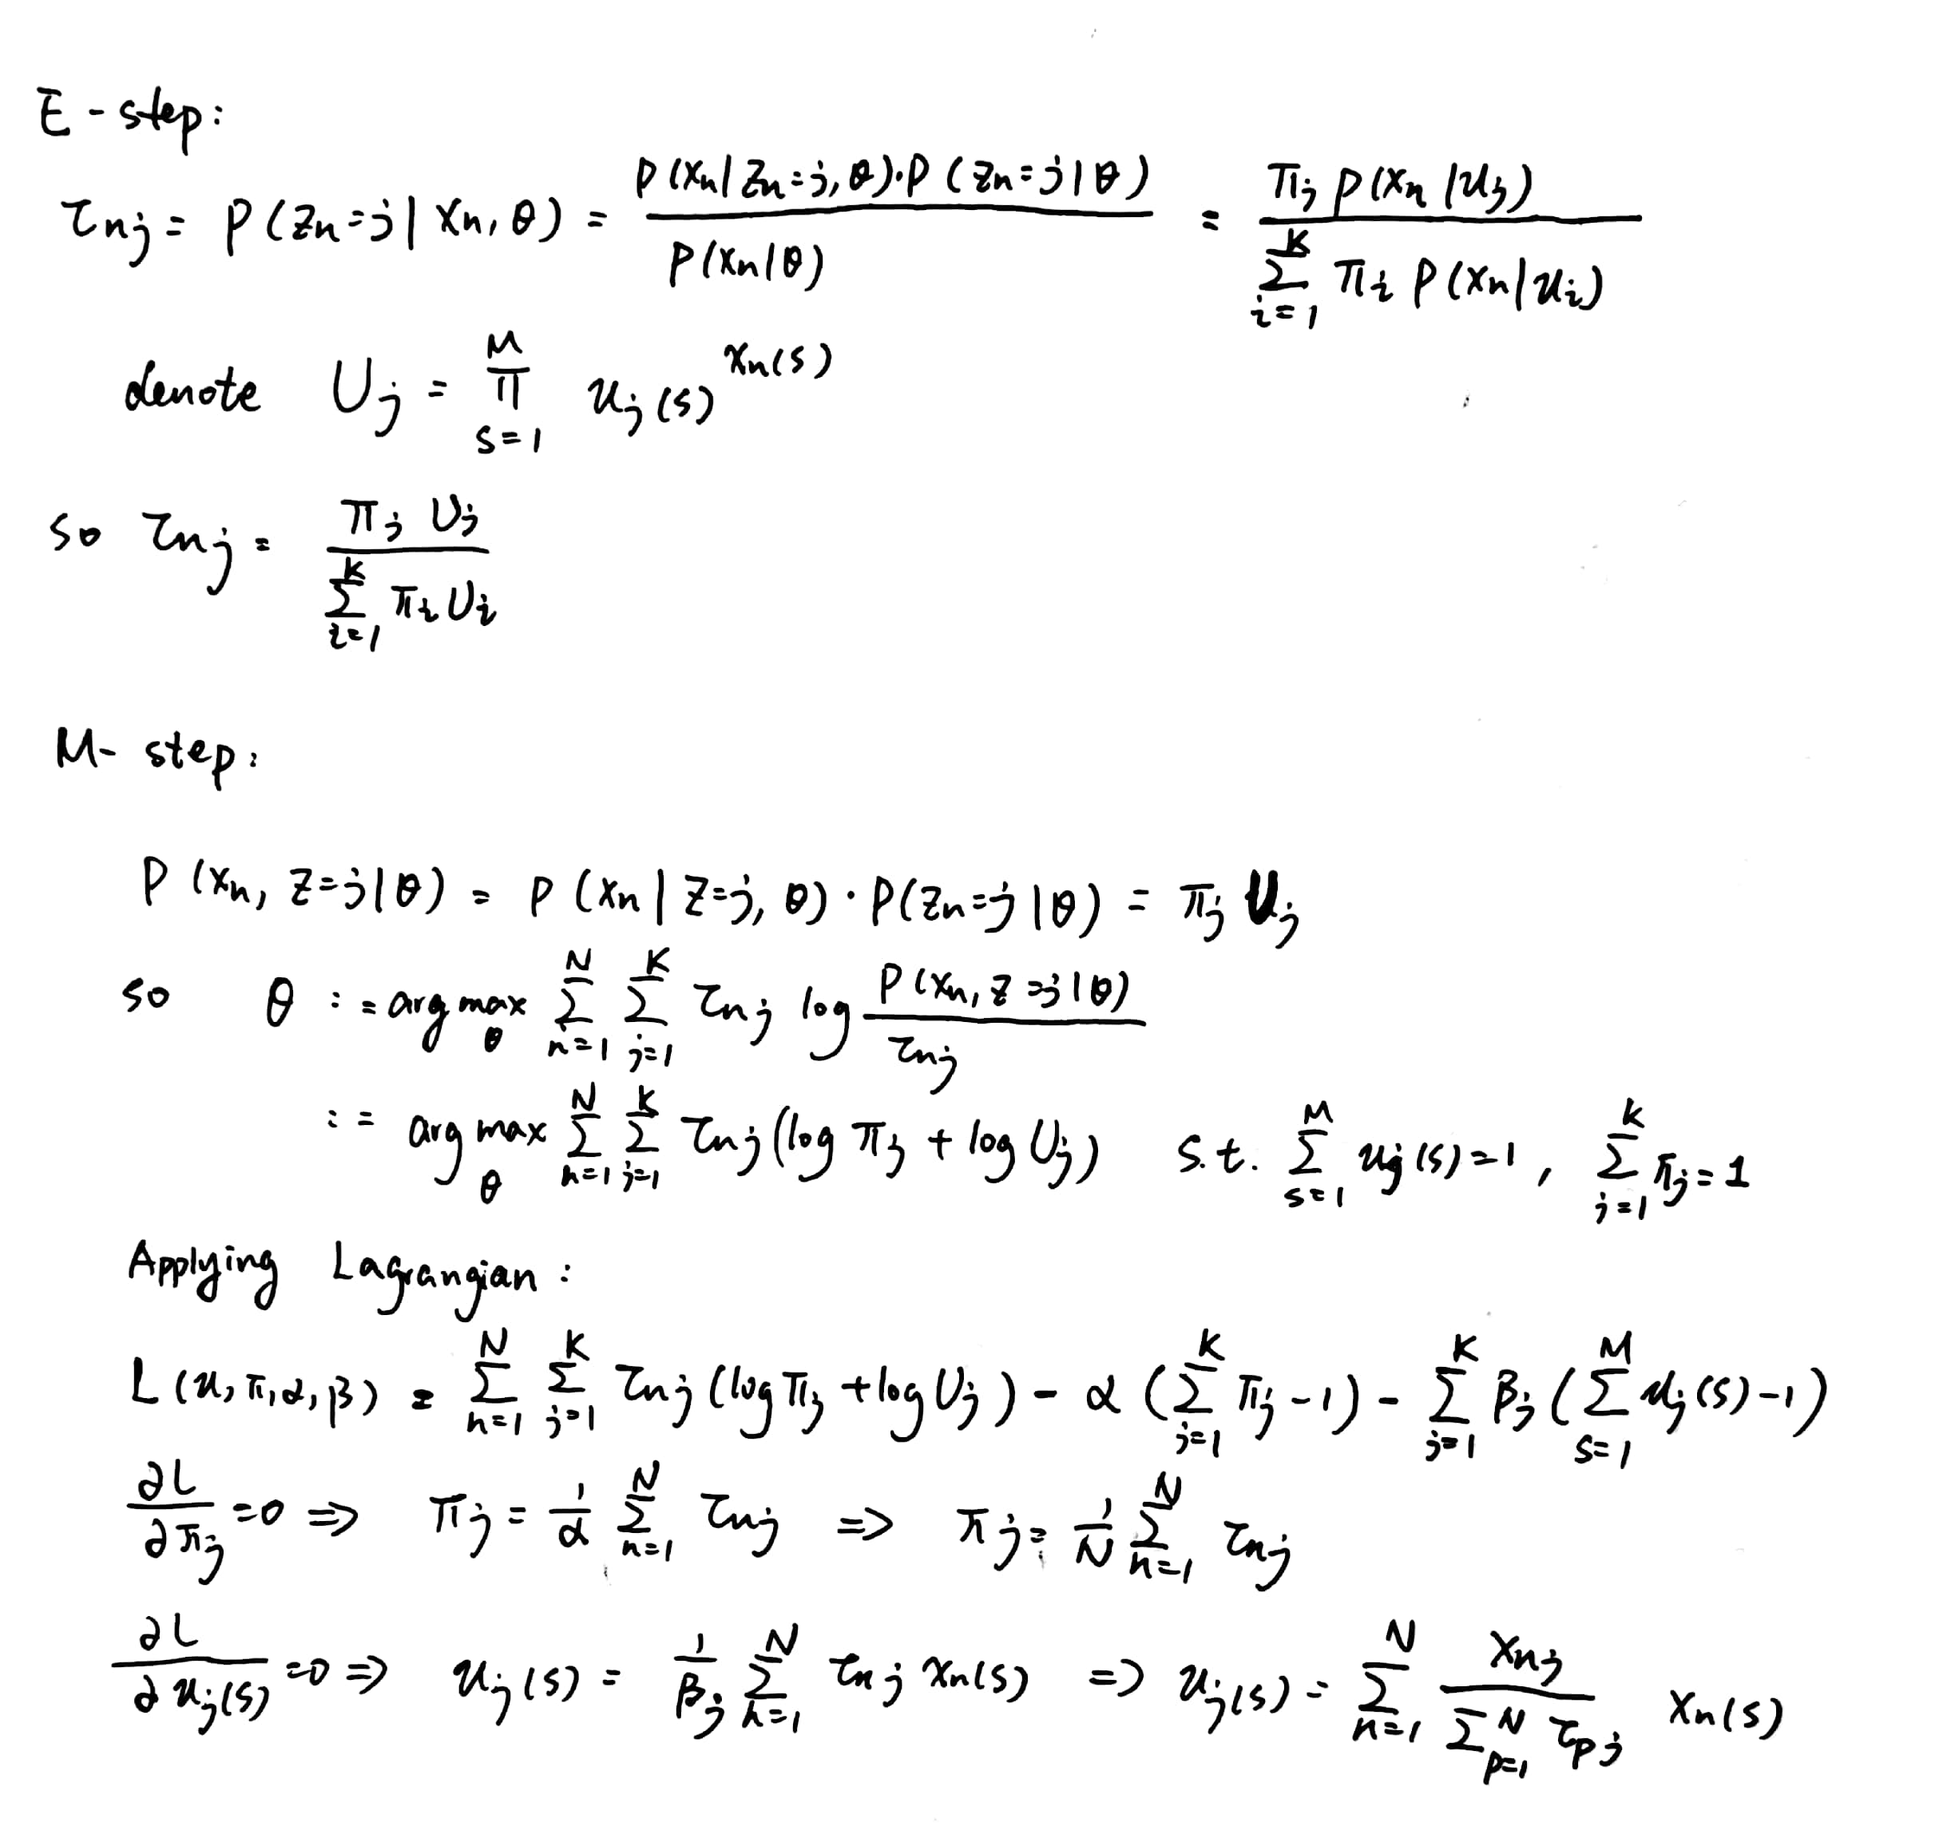

1. **Problem 2**

**Part A**

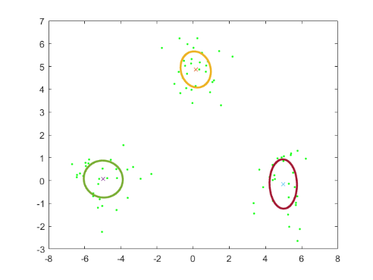 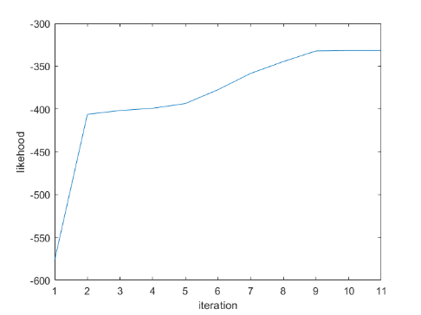

Dataset A iteration result

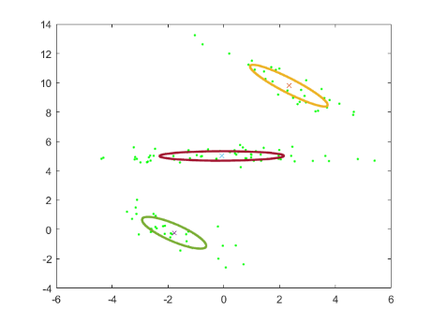 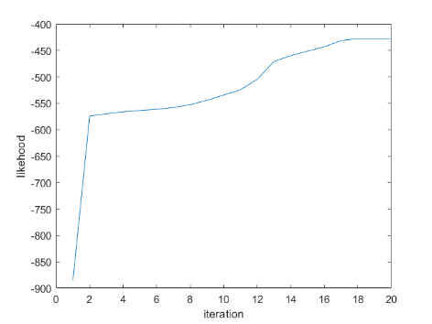

Dataset B iteration result

**Part B**

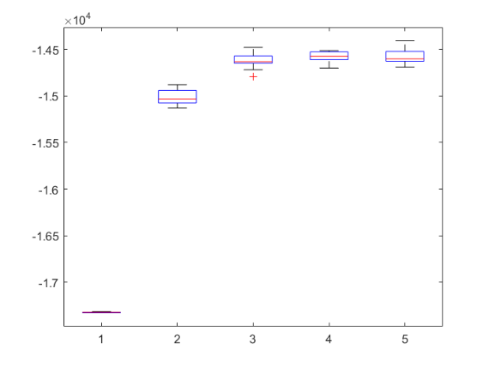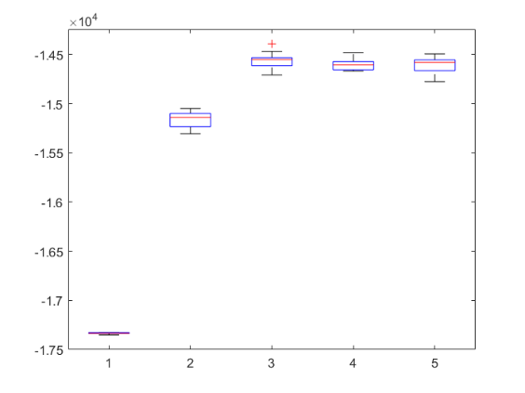

train log-likelihood average and std test log-likelihood average and std

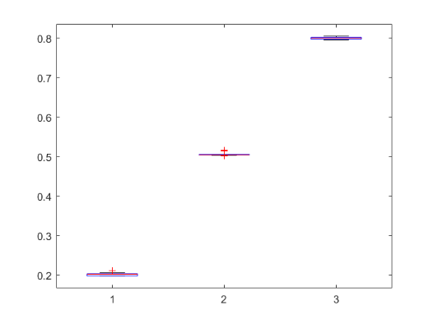 The Bernoulli coefficients are [0.2, 0.5, 0.8] in average

Optimal coefficients average and std

1. **Problem 3**



Original picture k = 3



K = 4 k = 5

For randomly initialized K means, some values might be too far away from data points thus lead to it is not closest mean to any point, this explains the inconsistencies.

Too improve, we should calculate a range according to the given dataset for the initial means. Also, we should make sure that every initial mean will not be too close to each other.

1. **Problem 4**

(a)

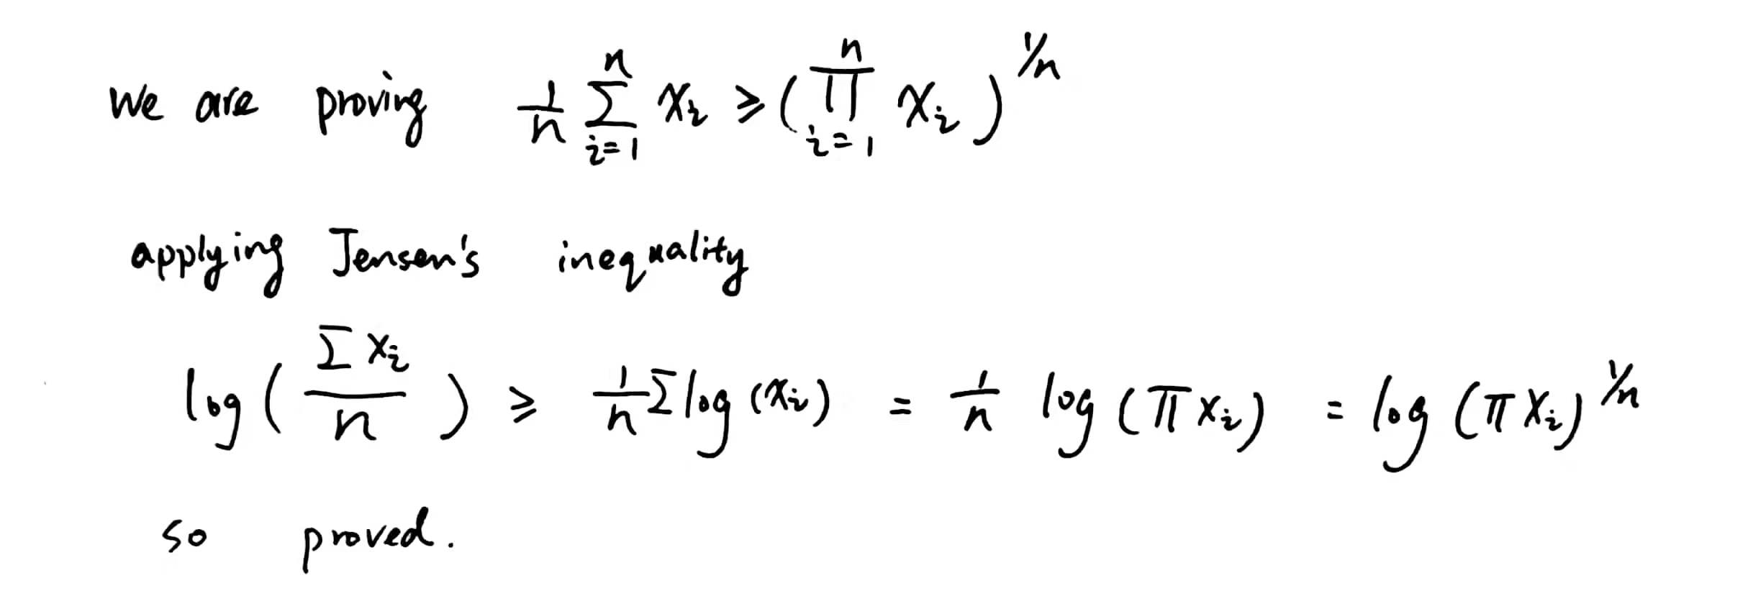

(b)

